**Assignment -2**

Flask Application And Database

|  |  |
| --- | --- |
| Student Name | Crosswin Kirubakaran D |
| Student Roll Number | 910019106008 |
| Maximum Marks | 2 Marks |

Question

1. Create Flask app
2. Add the Homepage , about page
3. Add the bootstrap
4. Add the sign in and add the Signup page with database connectivity
5. Use ibm-db2 as database

**Solution:**

**Flask Program**

from flask import Flask, render_template,request,redirect,url_for,session

import ibm_db

conn = ibm_db.connect("DATABASE=bludb;HOSTNAME=2d46b6b4-cbf6-40eb-bbce-6251e6ba0300.bs2io90l08kqb1od8lcg.databases.appdomain.cloud;PORT=32328;SECURITY=SSL;SSLServerCertificate=DigiCertGlobalRootCA.crt;UID=xvy82040;PWD=4F0vfOOKWVwTaDqA",'','')

app = Flask(__name__)

app.secret_key = b'_5#y2L"F4Q8z\n\xec]/'

@app.route('/',methods=['GET', 'POST'])

def Register():

session['msg']=""

if request.method == 'POST':

name = request.form['name']

email = request.form['email']

password = request.form['newpassword']

sql = "SELECT * FROM Users WHERE email =?"

stmt = ibm_db.prepare(conn, sql)

ibm_db.bind_param(stmt,1,email)

ibm_db.execute(stmt)

account = ibm_db.fetch_assoc(stmt)

if account:

session['msg']= 'Account already exists'

return redirect(url_for("login"))

else:

insert_sql = "INSERT INTO Users VALUES (?,?,?)"

prep_stmt = ibm_db.prepare(conn, insert_sql)

ibm_db.bind_param(prep_stmt, 1, name)

ibm_db.bind_param(prep_stmt, 2, email)

ibm_db.bind_param(prep_stmt, 3, password)

ibm_db.execute(prep_stmt)

session['msg']= 'New account created Login'

return redirect(url_for("login"))

return render_template('signup.html')

@app.route('/login',methods=['GET', 'POST'])

def login():

if request.method == 'POST':

email = request.form['email']

password = request.form['newpassword']

sql = "SELECT * FROM Users WHERE Email =?"

stmt = ibm_db.prepare(conn, sql)

ibm_db.bind_param(stmt,1,email)

ibm_db.execute(stmt)

account = ibm_db.fetch_both(stmt)

accounts=account

if (account):

if (password == accounts['PASSWORD'] ):

return render_template('Welcome.html',name=account['NAME'])

else :

return render_template('signin.html',msg='wrong Password')

else :

return render_template('signin.html',msg='wrong credentials')

else:

return render_template('signin.html',msg=session['msg'])

@app.route('/about')

def about():

return render_template('about.html')

@app.route('/home')

def home():

return render_template('home.html')

Templates/base.html

<!doctype html>

<html lang="en">

<head>

<meta charset="utf-8">

<meta name="viewport" content="width=device-width, initial-scale=1">

<link href="https://cdn.jsdelivr.net/npm/bootstrap@5.2.1/dist/css/bootstrap.min.css" rel="stylesheet" integrity="sha384-iYQeCzEYFbKjA/T2uDLTpkwGzCiq6soy8tYaI1GyVh/UjpbCx/TYkiZhlZB6+fzT" crossorigin="anonymous">

<!-- bootstrap 5-->

{% block head %} {% endblock %}

</head>

<body>

<nav class="navbar navbar-expand-lg navbar-light bg-light">

<div class="container-fluid">

<a class="navbar-brand" href="/home">Navigation</a>

<button

class="navbar-toggler"

type="button"

data-mdb-toggle="collapse"

data-mdb-target="#navbarNav"

aria-controls="navbarNav"

aria-expanded="false"

aria-label="Toggle navigation"

>

<i class="fas fa-bars">Menu</i>

</button>

<div class="collapse navbar-collapse" id="navbarNav">

<ul class="navbar-nav">

<li class="nav-item">

<a class="nav-link active" href="{{url_for('home')}}">Home</a>

</li>

<li class="nav-item">

<a class="nav-link" href="{{url_for('Register')}}">Register</a>

</li>

<li class="nav-item">

<a class="nav-link" href="{{url_for('login')}}">Login</a>

</li>

<li class="nav-item">

<a class="nav-link" href="{{url_for('about')}}">About</a

>

</li>

</ul>

</div>

</div>

</nav>

{% block body %} {% endblock %}

<script src="https://cdn.jsdelivr.net/npm/bootstrap@5.2.1/dist/js/bootstrap.bundle.min.js" integrity="sha384-u1OknCvxWvY5kfmNBILK2hRnQC3Pr17a+RTT6rIHI7NnikvbZlHgTPOOmMi466C8" crossorigin="anonymous"></script>

</body>

Home.html

{% extends 'base.html' %}

{% block head %}

<title>Home</title>

{% endblock %}

{% block body %}

<div class='container'>

<h1>HOMEPAGE</h1>

<p>Welcome to Flask app!</p>

</div>

{% endblock %}

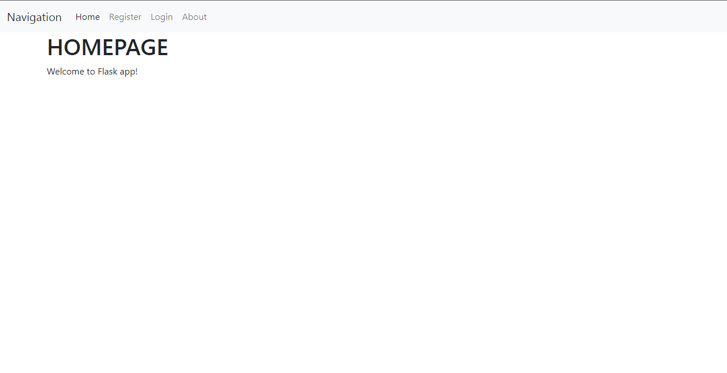

Signin.html

{% extends 'base.html' %}

{% block head %}

<title>Login</title>

{% endblock %}

{% block body %}

<div class='container'>

<div class="registration-form" >

<h1>Login</h1>

<h2>{{msg}}</h2>

<form name="form_login" action="/login" method="POST">

<div><label for="input_registration_email" class="form-label">Email</label>

<input type="text" name="email" class="form-control" id="input_registration_email" maxlength="50" placeholder="@"></div>

<div><label for="input_registration_newpassword" class="form-label">Password</label>

<input type="password" name="newpassword" class="form-control" id="input_registration_newpassword" maxlength="30" >

</div>

<button type="submit" class="btn_general btn_blue mt-2" id="button_registration_submit">Sign In</button>

</form>

</div>

</div>

{% endblock %}

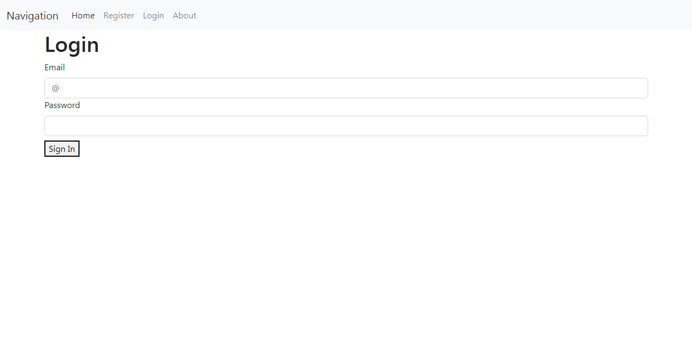

Signup.html

{% extends 'base.html' %}

{% block head %}

<title>Registration</title>

{% endblock %}

{% block body %}

<div class='container'>

<div class="registration-form" >

<h1>Registration Form</h1>

<form name="form_login" action='/' method="post">

<div><label for="input_registration_name" class="form-label">Name</label>

<input type="text" name="name" class="form-control" id="input_registration_name" maxlength="50"></div>

<div><label for="input_registration_email" class="form-label">Email</label>

<input type="email" name="email" class="form-control" id="input_registration_email" maxlength="50" placeholder="@"></div>

<div><label for="input_registration_newpassword" class="form-label">New Password</label>

<input type="password" name="newpassword" class="form-control" id="input_registration_newpassword" maxlength="30" placeholder="******">

</div>

<button type="submit" class="btn btn-primary" id="button_registration_susbmit">Sign up</button>

</form>

</div>

</div>

{% endblock %}

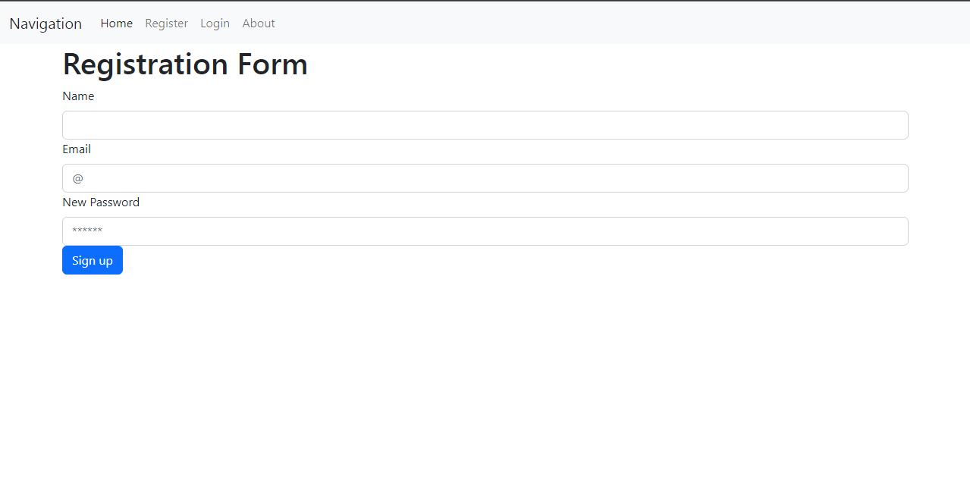

Welcome.html

{% extends 'base.html' %}

{% block head %}

<title>Welcome</title>

{% endblock %}

{% block body %}

<h1 class="display-1">Welcome to the portal {{name}} You have logged in</h1>

{% endblock %}

About.html

{% extends 'base.html' %}

{% block head %}

<title>About</title>

{% endblock %}

{% block body %}

<div class='container'>

<h1>About</h1>

<p>This is the second assingment for Cloud application Development</p>

</div>

{% endblock %}

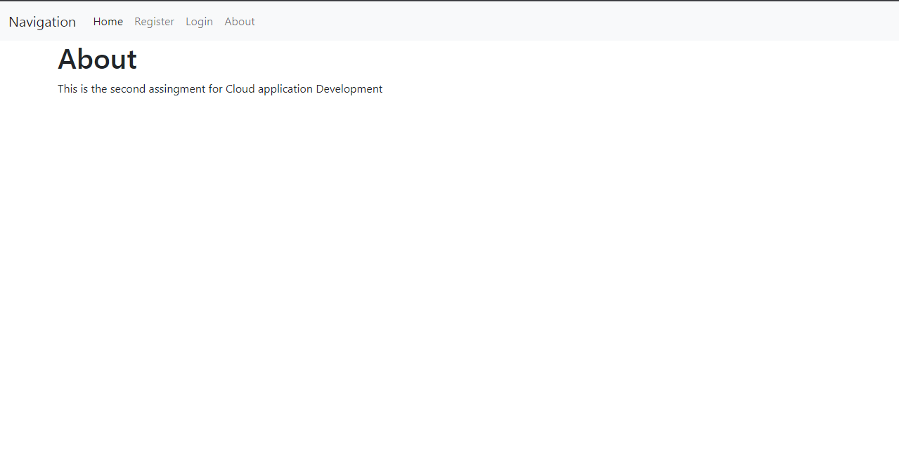

Working

1.When name, email, password are filled in registration page, the credentials are stored in IBM DB2 and redirected to the login page

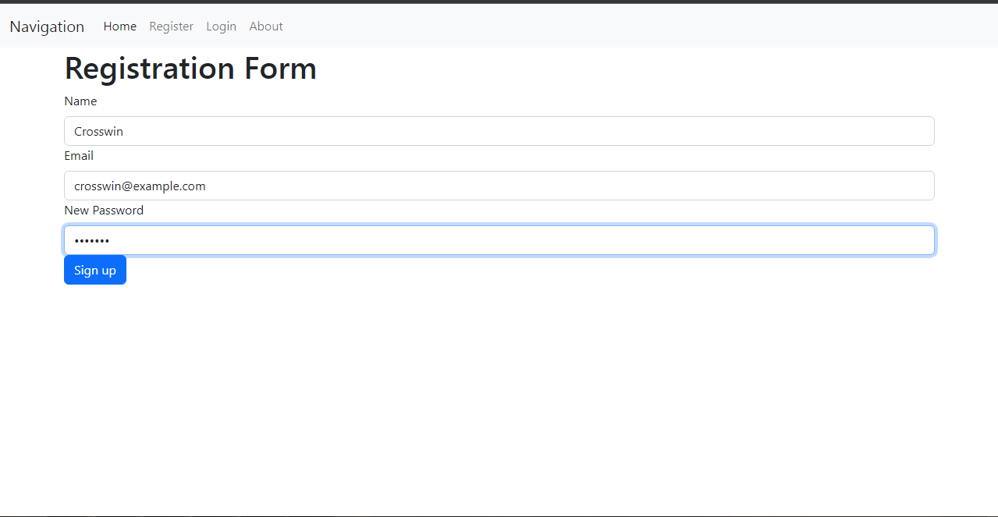

Data in Table

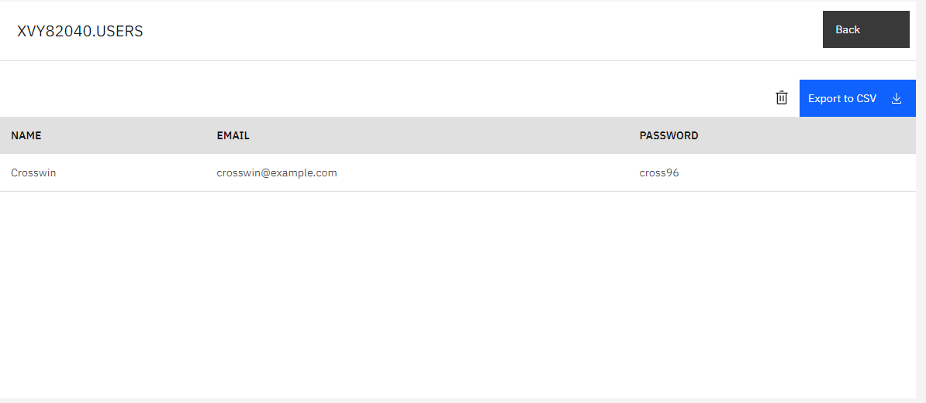

2. Enter Details in Login page if details are correct welcome message is shown

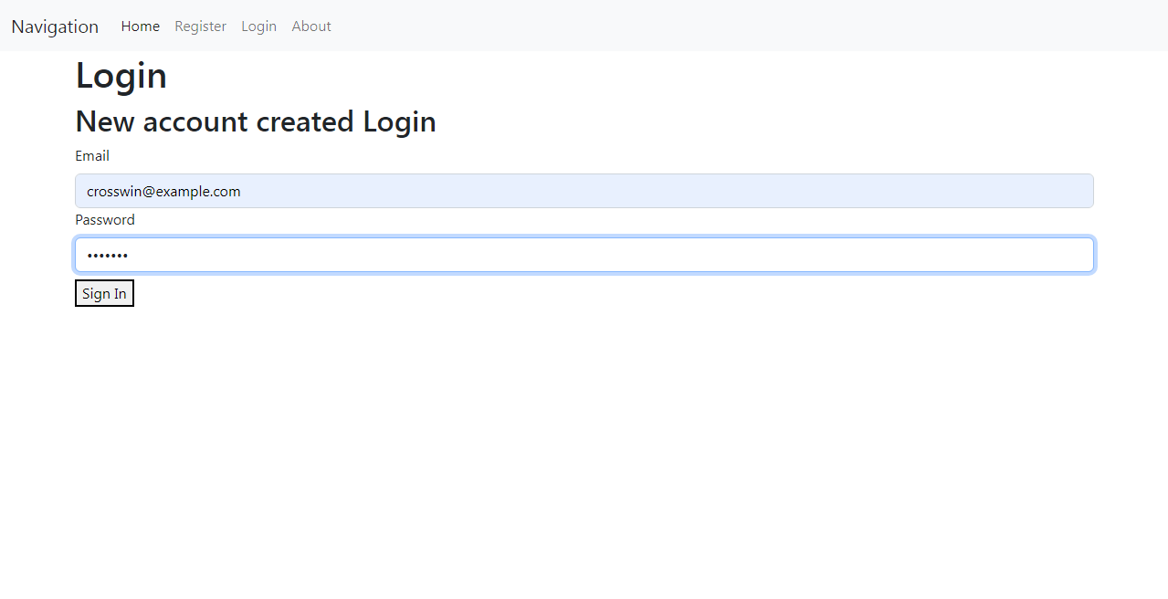

The Welcome page that is shown

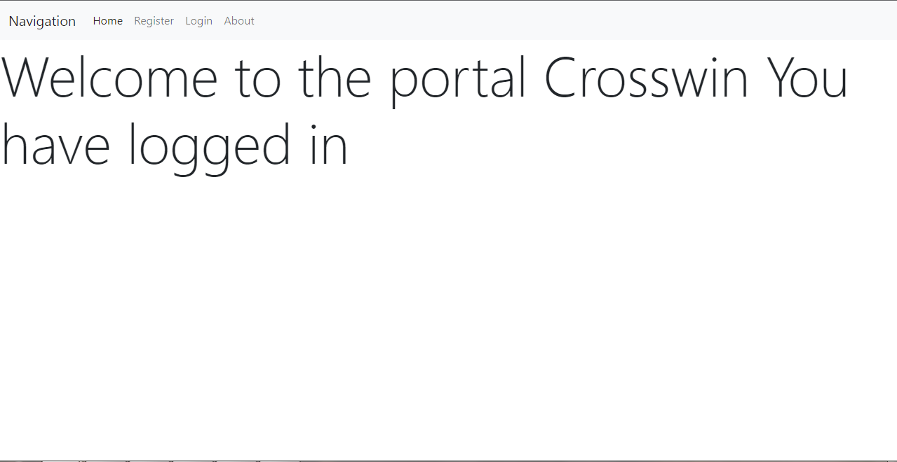

If the entered Credentials are wrong , the following message will be shown

